Objectives

- Explain React Forms validation
- Identify the differences between React Form and HTML Form
- Explain about controlled components
- Identify various React Form input controls
- Explain how to handle React Forms
- Explain about submitting forms in React

In this hands-on lab, you will learn how to:
- Implement React forms validation
- Use various input controls like textbox, button and textarea

Prerequisites

The following is required to complete this hands-on lab:
- Node.js
- NPM
- Visual Studio Code

Notes

Estimated time to complete this lab: 60 minutes.
Create a React App named “mailregisterapp” which will have a component named “register.js”. Create a form which accepts the name, email and password and validate the fields as per the following:

- Name should have atleast 5 characters
- Email should have @ and .
- Password should have atleast 8 characters.

Ensure that validations are implemented through eventhandle and eventsubmit of a form.

Output Expected:

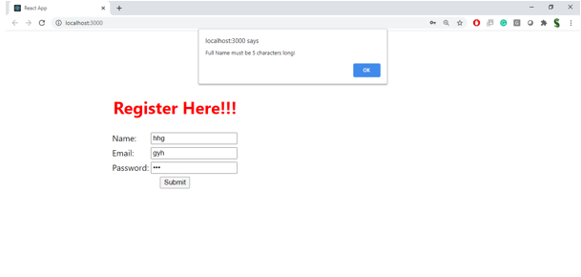

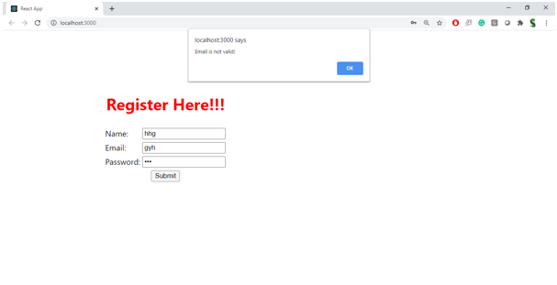

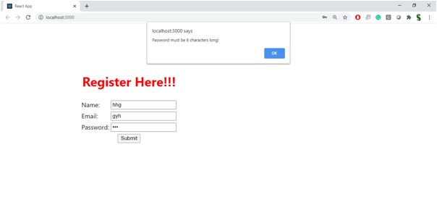

Hint:

